Awana Calendar – Fall 2019

**August**

**21st: First Awana night.** (ps - it’s always “Bring a Friend” night, too)

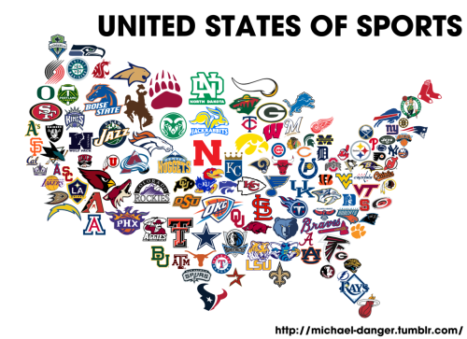**28th:** It’s National Bow Tie day!!!

**September**

**4th:** NFL Kickoff – wear your favorite football uniform

**11th:** Crazy Hat & Sock Night

**18th:** Plain ol’ Awana night – so glad you’re here!!!

**25th: Chick Fil A Celebration Night – wear your best cow costume!**

**October** 

**9th**: F A L L B R E A K - no Awana

**16th**: **Canned good night.** Let’s build a big pile of food in the foyer to give to those in need.

**23rd**: **Pajama night** – princesses, stuffed animals, and super heroes welcomed.

**30**th: Ain’t nothin’ scary ‘bout the Holy Spirit! 

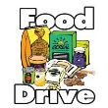

**6th: Fall colors – dress in browns and oranges**

**13th:** **F o o d D r i v e !!!**



**20th:** It’s another Awana night… YAY!!!

**28th: Thanksgiving break**

**December**

**4th:** **Green** and **Red** night. Wear your holiday green and/or red colors. **The brighter, the better!**

**11th:** **Awana STORE!!!!**

(**Awana will return January 8th, 2020**)

Awana Calendar – Spring 2019

**January**

**8th:**

**15th:**

**22nd:**

**29th:**

**February**

**5th:**

**12th:**

**19th:**

**26th:**

**March**

**4th:**

**11th:**

**18th:** SPRING BREAK

**25th:**

**April**

**1st:**

**8th:**

**15th:**

**22nd:**

**29th:**

**May**

**6th:**

**13th:**